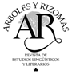

***Árboles y Rizomas.***

***Revista de Estudios Lingüísticos y Literarios***

***ISSN 0719-9805***

**Biodata for Authors (no more than 200 words)**

Include name, degree, academic affiliation, research interests, country, mailing address, mobile phone, and e-mail.